CLIMATE CHANGE: A SCIENTIFIC PRIMER
Michael Breakspear
January 13th, 2020

There is compelling evidence for human-caused climate change, principally due to the production and release of carbon dioxide into the atmosphere. The associated heating is accelerating the loss of species, ecosystems and biodiversity, increasing fire risk and will cause substantial future mortality and economic damage. Although the public increasingly accept the science and importance of climate change, there remains substantial inertia regarding effective policy and action.
This document briefly reviews the physics and peer-reviewed science of anthropogenic climate change – with a focus on fire risk - for those wishing closer familiarity with the peer reviewed literature.
Sources used in the following sections include scientific peer-reviewed research papers [papers], reports and briefing to the Australian federal government [reports], third-party scientific websites [sites] and where relevant to specific instances, [media] reports.
- Climate change; the Australian context 2
- Is the climate changing? 5
- Is it due to human activity? 7
- Is it “normal variation”? 10
- Climate change and bushfires 13
- Impact of climate change on economic activity and human mortality 18
- Action to arrest further climate change 21
- What is not causing climate change 28
- Source material 35

1. CLIMATE CHANGE, THE AUSTRALIAN CONTEXT
The last few years have seen a series of exceptional natural events in Australia: Mass bleaching on the Great Barrier Reef, heat waves causing wholesale deaths of native species, record dry spells (all documented below). Following the driest spring on record [report], large and destructive bushfires have burned through millions of hectares of bushland and grassland across much of Australia. These fires are unusual in their number (hundreds, burning through millions of hectares), intensity (many burning out of control and generating ‘fire tornadoes’), the places they have burned (including rainforests that have not historically burned), and their duration (now into their third continuous month).
There is compelling scientific evidence for human-caused global climate – mainly heating and its consequences, but also ocean acidification. There is strong scientific evidence that these changes increase fire risk, lengthen the fire season and contribute to fire intensity. For example, a substantial proportion of recent fires in the USA [paper] and Canada [paper] can be attributed to climate change. Yet mention of the link between climate change and the bushfires in Australia has become a divisive, contested and emotive topic.
According to recent polls [report], Australians overwhelmingly (~90%) accept the fimdimgs of climate change, and an increasing number of Australians (>60%) are prepared to take immediate steps even if that involves significant costs (Fig. 1):
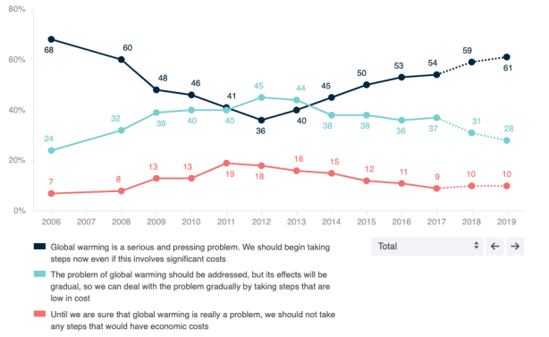
Figure 1: Australians attitudes to climate change [report].

Among younger Australians, only 1% polled stated that we should adopt a “wait and watch” approach (Fig. 2):
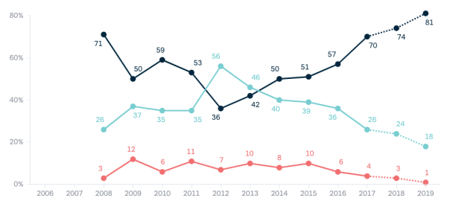
Figure 2: Attitudes to climate change in young Australians (18-29 yrs) [report]
Despite the public sentiment supporting climate science, much of the language in the public domain since the bushfires has been acrimonious and hostile. There has been commentary in legacy and social media (including that coming from elected politicians) that clearly does not support climate science and as a result, there is a lot of information in the public domain that is contrary to peer reviewed science. Commentary from some of Australia’s political leaders has been at best ambivalent.
As reviewed in Section 3, scientific research that now stretches back for nearly 50 years has unambiguously a causal role of carbon dioxide (CO2) emissions arising from human activity in global heating and associated climate changes. established However, despitr public sentiment, Australian government reports show that CO2 emissions continue to rise across major sectors of the Australian economy [report].
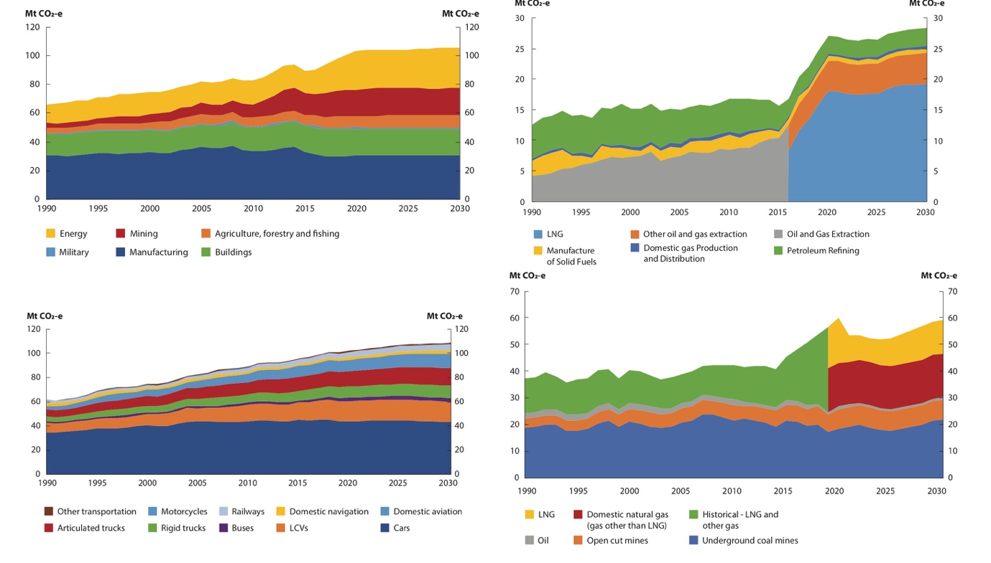
Figure 3: Emission trends in the Australian energy sector (top left); from direct combustion (top right); the transport sector (bottom left); and “fugitive emissions” from fossil fuels (bottom right) [report].
Although partly offset by changes in the “land use and forestry” sector, these emission rises are fundamentally inconsistent with the deep cuts required to stabilize global heating below critical levels (see below). Australia is the world’s third biggest exporter and fifth biggest miner of fossil fuels by CO₂ potential (Fig. 4). Its exports are behind only Russia and Saudi Arabia, and far larger than Iraq, Venezuela and any country in the EU [report]. It is easily the biggest exporter of coal, more than the combined exports of the next three countries (Indonesia, Russia, USA) [report].
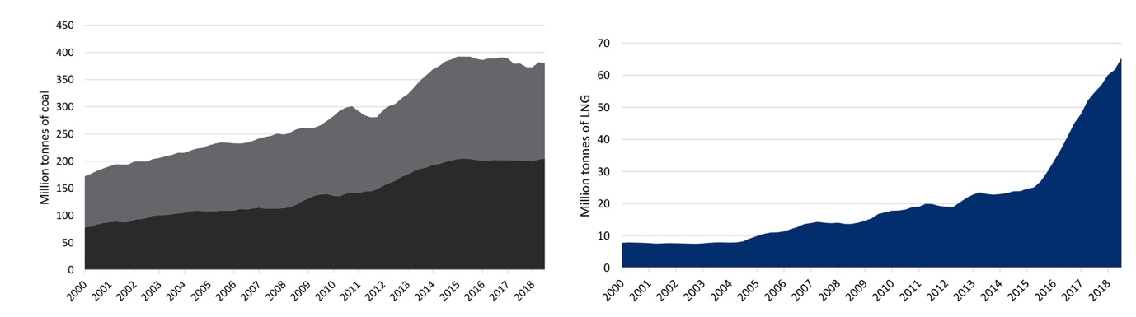
Figure 4: Australia’s increasing export of fossil fuels: Thermal (black) and coking (grey) coal (left) and liquid natural gas (right)
There already exist numerous independent overviews of the existence and impact of climate change, including that hosted by NASA [report] as well as Australia’s Commonwealth Science and Industry Research Organization (CSIRO) [report]. NASA put “man on the moon” and the CSIRO developed the wifi [report] – one would think these achievements would impart them with broad scientific authority in the community. An international consortium of scientists – the “Inter-governmental Panel on Climate Change” (IPCC) publish regular, extensive reports on the magnitude of global heating and the associated scientific methods [report]. These are subject to strict independent peer review. Yet, in today’s contested social media and political landscape, even these entities have been claimed as compromised, a point I touch on below.
This primer is a collation of basic resources on climate change, its causes and impacts, with a special focus on Australia. Through the footnotes, all the major claims in the primer are linked directly to peer reviewed papers, which can be accessed and read. The purpose of this document is to provide direct links to peer reviewed papers, and to collate a brief but overall perspective for those interested in obtaining information for discussion in the current heated social environment. Engaging in this issue through social media has also led me to make some reflections on the sociological role of science and knowledge which I add at the end.

2. IS THE CLIMATE CHANGING?
Comprehensive analyses unambiguously support the presence of substantial global heating. These include temperatures averaged over a large number of regional centres (such as Australia) and globally (Fig. 5). They include multiple aspects of “climate” including surface and atmospheric temperatures, surface ocean temperature and lake temperatures. This is reflected in the mean temperature as well as the number of hot days and, because warm water expands, rising sea levels. A large body of work documents this, but a comprehensive summary can be found in a “State of the Climate” report by the American Meteorological Society, with over 100 contributing scientific authors [paper], as well as regular reports by Australia’s CSIRO and Bureau of Meteorology [report; see also site].
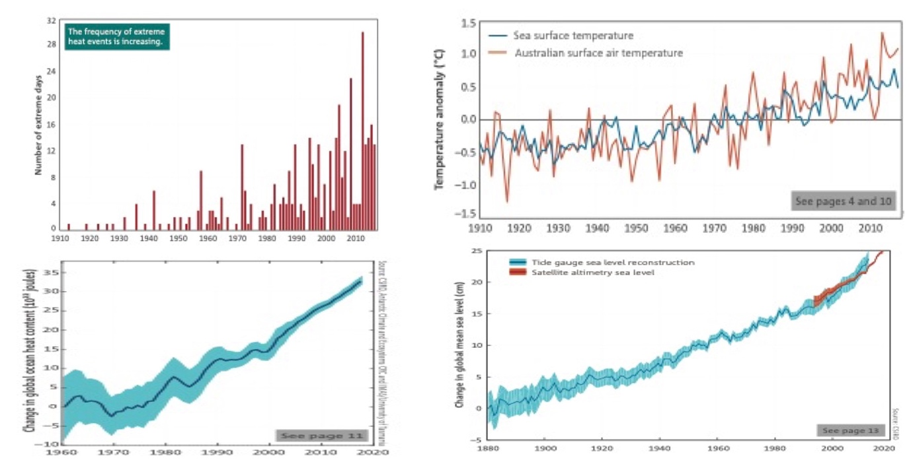
Figure 5: A snapshot of climate change indices [report], including number of hot days (top left); temperature anomalies (top right), ocean heat (bottom left) and sea levels (bottom right)
There naturally exist local deviations in all of these indices, such as instances of cold weather. Likewise, in “recent times” (centuries), there have been instances of regional heating and cooling. However, there is no evidence for globally coherent warm or cold periods in the last 2000 years that compare with the widespread heating of the present era (Fig. 6)
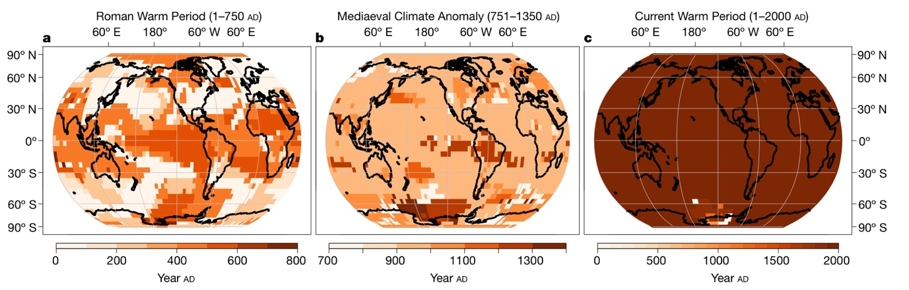
Figure 6: No evidence for globally coherent warm periods in the last 2000 years. Colours depict spread of years for local maximum temperatures during the Roman Period (left), the Medieaval Period (centre) and the present period (right) with far greater global coherence [paper].
Notably, global heating is evident when inferring temperature from other meteorological observables including barometric pressure [paper], and from recent satellite estimates of global temperature in the mid- to upper troposphere [paper]. These studies invalidate spurious claims occasionally made in the public domain that historical surface recordings, or their analyses, are unreliable.

3. IS CLIMATE CHANGE DUE TO HUMAN ACTIVITY?
Carbon dioxide (CO₂) is a heat trapping gas. More technically, it absorbs the infra-red energy radiating from the earth’s surface and turns this into thermal energy (heat), a process known as “radiative forcing”. Other gases such as methane and nitrous oxide trap heat even more effectively, although the rate of their release into the atmosphere is less than CO₂. Indeed, without these gases and water vapour, the earth’s atmosphere would be too cold to support life as we know it. Industrial activity releases carbon dioxide into the atmosphere, principally through burning of fossil fuels for energy production and transport. The global growth rate of CO₂ has nearly quadrupled since the early 1960s (Fig. 7a).
The annual global average carbon dioxide concentration at Earth’s surface for 2017 was the highest in the modern atmospheric measurement record and in ice core records dating back as far as 800 000 years. Because carbon dioxide dissolves into sea water to form carbonic acid, the impact of this increase can be also seen in changes in the ocean’s pH (Fig. 7b).
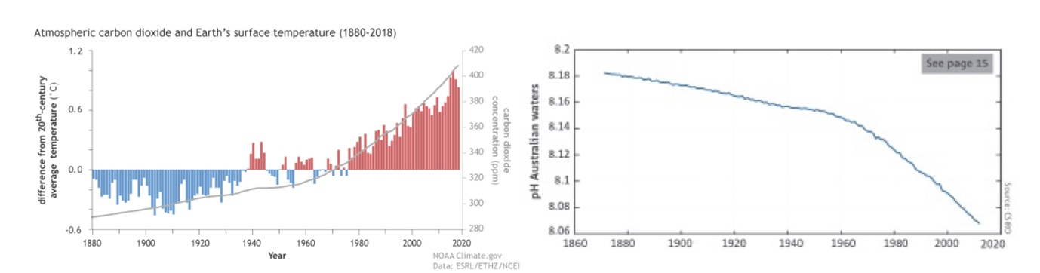
Figure 7: (left) Increasing global (land and sea) surface temperature (bars) and atmospheric CO₂ (gray line) [site]; (right) Acidification (lowering pH) of Australian waters [report].
The “heat-trapping” effect of CO₂ can be measured and incorporated into comprehensive climate models (mathematical models of heat transfer and atmospheric kinetics) which can then be fit to temperature recordings and evaluated (see below).
Just to note that weather forecasting involves modelling the movement of gases (atmosphere) and fluids (oceans) in the presence of heating – these have become astonishing in their complexity and can be viewed in the public domain through websites such as www.windy.com. However, the so-called “nonlinearities” in these models amplify fluctuations and gives weather forecasting a temporal window of only about 10 days until “chaos” takes effect. For example, if the wind speed doubles, the gusts above the mean also increase substantially (Fig. 8): This feedforward amplification is relevant to all aspects of weather systems: increases in extreme events can be “super-additive” to increases in the average: The same effect is apparent in the super-additive increase in the number of very hot days (Fig. 5).
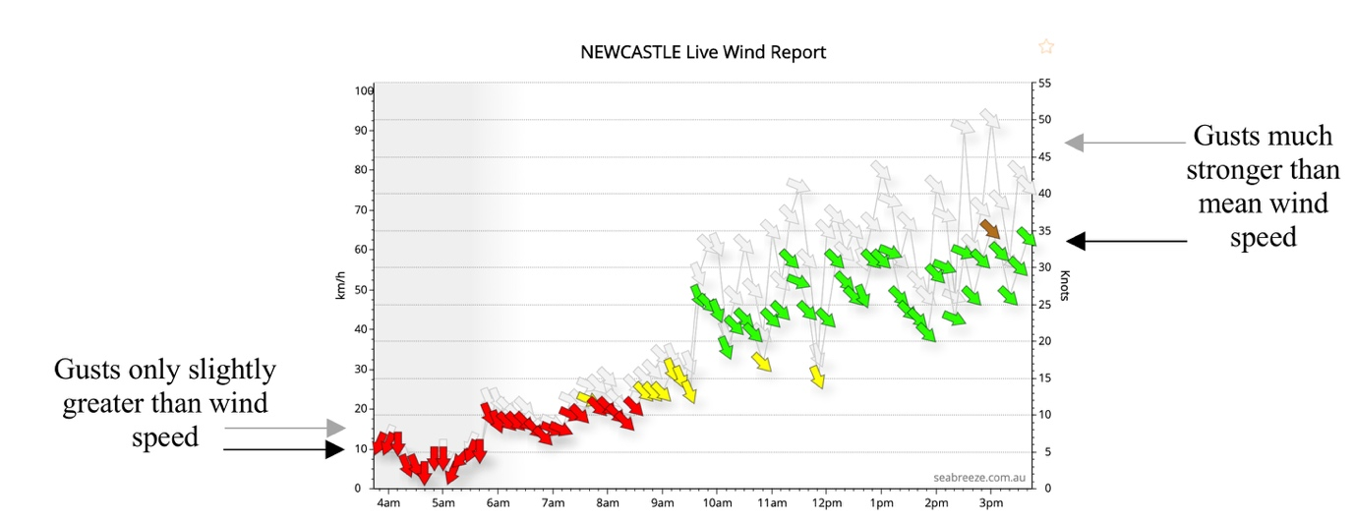
Figure 8: Wind speeds on a typical day in Newcastle. As mean wind speed increases through the day from ~10km/h to 35 km/h, the additional gusts increase from 3km/h to over 15km/h [site]
In contrast to weather, climate modelling addresses longer time scales. This is achieved by using a standard technique in physics known as the separation of time scales. In this manner, only slow changes in meteorological observables are modelled, consistent with the physics of the ocean, land and atmosphere (the fast, chaotic fluctuations no longer degrade forecast accuracy). As in all branches of science, climate models can be fit to data and evaluated; different models can be compared; and good models are incrementally improved through the process of data fitting, evaluation and innovation [site]. To ensure that models don’t become more complicated than they need to be, models can also be penalized by their complexity (roughly, how many parameters they contain).
Initial predictions of global heating due to increases in atmospheric CO2 were published nearly 50 years ago [paper]. Reasonably complex climate models, incorporating radiative forcing, were developed in the 1980s and predict global heating with remarkable accuracy, considering the limited computational resources available at the time [paper, paper].
Climate modelling is now a mature scientific field, implemented globally by mass supercomputer simulations [paper]. As more complex negative and positive feedback loops have been incorporated (such as the mixed effects of clouds), these models have converged toward the observed heating with increasing accuracy [site].
Those models that contain the terms for the heating effect of carbon dioxide in the atmosphere do a far better job at explaining and predicting measurements than those models that do not, even when a litany of other effects are modelled. For example, scientists from the CSIRO have shown that there is less than 1 in 100,000 chance that global average temperature over the past 60 years would have been as high without human-caused greenhouse gas emissions [paper]. The empirical data used in this paper is available in the public domain for anyone to simulate and compare a competing model of climate change, such as one without radiative forcing or with other putative effects such as fluctuating solar heating.
The current models of atmospheric physics that support “man-made” climate change were recently summarised in a paper co-authored by over 100 scientists and subject to multiple rounds of independent peer review [paper]. The next update will be published in 2021 following a five-month open call for contributions.
NASA and 200 of the world’s other leading scientific organizations unequivocally support the science of man-made climate change [site]. This includes the American Physical Society (who publish the world’s leading physics journals) and the American Association for the Advancement of Science (who publish Science).
Global heating depends on the Equilibrium Climate Sensitivity (ECS), which relates atmospheric CO₂ concentration to atmospheric temperature. For decades, ECS has been estimated to be between 2.0° and 4.6°C, with much of that uncertainty owing to the difficulty of establishing the effects of clouds on the Earth’s energy budget. A recent study in the prestigious journal Science concluded that projected ECS could be between 5.0° and 5.3°C [paper].

4. IS CLIMATE CHANGE “NORMAL VARIATION”?
4.1 Statistical meaning of “normal variation”.
As pointed out above, there is an upward trend in the global temperature over a period of decades to centuries, statistically incompatible with variation around a stable mean. When the mean moves outside its prior zone of uncertainty, it is necessary to conclude that it is “changing”. Modelling and observation both definitively support the role of increasing atmospheric CO₂ in that process.
Climate has varied before and there obviously continues underlying year-to-year fluctuations. But such past changes have occurred on much slower time-scales than occurring currently unless precipitated by a cataclysmic event such as a meteor. Also, because much of the warming can be attributed to the increase in heat trapping gases arising from human activity, it is not “normal” variation (see Section 3).
4.2 Evidence from impact on marine species:
Despite this, the “normal variation” claim is often raised. Another way to benchmark current climate heating against natural variation is to look at its impact on biodiversity. One of the core assumptions of evolution is that species adapt to survive in their ecological niche. On this measure, climate change is contributing to the extinction of both land and marine species. Rapid and widespread extinction events due to heat are not consistent with “normal variation.”
Perhaps the clearest example is the bleaching and collapse of the Great Barrier Reef (GBR), which is a diverse ecological phenomenon comprising thousands of coral and related species. Widespread bleaching events occurred on the GBR in 1998, 2002, 2016 and 2017. Although coral can recover from local bleaching events,
“The time between recurrent events is increasingly too short to allow a full recovery of mature coral assemblages, which generally takes from 10 to 15 years for the fastest growing species and far longer for the full complement of life histories and morphologies of older assemblages … we are already approaching a scenario in which every hot summer, with or without an El Niño event, has the potential to cause bleaching and mortality at a regional scale” [paper].
In other words, current rates and depths of coral bleaching exceed the bounds of the ability of coral to adapt and recover, incompatible with natural variation.
Opponents to this view often argue that there have been previous bleaching events. But, like global temperature, the current rate and depth of bleaching is not normal, a calculation recently made possible by the generation of a high-resolution global mass coral bleaching database [paper],
“Recurrent regional-scale (>1000 km) bleaching and mortality of corals is a modern phenomenon caused by anthropogenic global warming: Bleaching before the 1980s was recorded only at a local scale of a few tens of kilometres because of small-scale stressors such as freshwater inundation, sedimentation, or unusually cold or hot weather. The modern emergence of regional-scale bleaching is also evident from the growth bands of old Caribbean corals: synchronous distortions of skeletal deposition (stress bands) along a 400-km stretch of the Mesoamerican Reef have only been found after recent hot conditions, confirming that regional-scale heat stress is a modern phenomenon caused by anthropogenic global warming.”
and,
“The 2015-2016 global bleaching event is a watershed for the Great Barrier Reef, and for many other severely affected reefs elsewhere in the Indo-Pacific. The most likely scenario, therefore, is that coral reefs throughout the tropics will continue to degrade. The 2016 marine heatwave has triggered the initial phase of that transition on the northern, most pristine region of the Great Barrier Reef, changing it forever as the intensity of global warming continues to escalate. The large-scale loss of functionally-diverse corals is a harbinger of further radical shifts in the condition and dynamics of all marine ecosystems.” [paper].
Not just the GBR, but also,
“Coral reefs across the world’s oceans are in the midst of the longest bleaching event on record … the period of summer-like temperatures has become longer through the record, with a corresponding shortening of the ‘winter’ reprieve from warm temperatures. The frequency of bleaching-level thermal stress increased three-fold between 1985–91 and 2006–12.” [paper]
As recently concluded in a Nature article, “Immediate global action to curb future warming is essential to secure a future for coral reefs.” [paper]
It is tempting to view a coral bleaching event as an isolated incident due to a combination of local ocean currents and cloudless days. But of fundamental concern is that coral bleaching is just one manifestation of marine heatwaves that are increasing across all marine environments. From 1925 to 2016, the number of marine heatwaves occurring globally increased by 54% [paper]. For example, an unprecedented marine heatwave in the Tasman Sea in 2015 was 300 times more likely to be due to anthropogenic climate change than to natural variation [paper].
Marine heatwaves represent a substantial threat to global marine species, from predator species [paper] to molluscs [paper], seaweed (kelp) [paper] and to species at the bottom of the food chain such as plankton [paper]. Because of the enormous biological reservoir of the ocean, and the role of marine species in atmospheric gas exchange, extinction events amongst marine species are of substantial concern. This is particularly true of plankton, which fixate ∼45 gigatons of organic carbon per annum [paper] and are a food source for many other marine species.
4.3 Evidence from impact on terrestrial species:
The broader lens to view the global collapse of coral reefs is through the widespread, accelerated loss of terrestrial and marine species: Current extinction rates are approximately 100 times above the background rate, far outstripping the appearance of new species [paper]. As with marine species, terrestrial species across the breadth of the food chain are being lost, with as many as one million species facing extinction [paper]. This includes the loss of as much as three quarters of total insect biomass (including bees, moths, butterflies) since 1990 [paper]; Over 40% of insect species are threatened with extinction [paper]. As with plankton, the loss of insects is particularly concerning as in addition to their role in pollination and nutrient cycling, they are a major food source for birds, mammals and amphibians. The extent of future global heating will impact substantially here: If warming is limited to 1.5°C as compared with 2°C, the numbers of insect species projected to halve in number is reduced by two thirds [paper].
The causes of this accelerated extinction rate are diverse, but clearly do not sit within the boundaries of “normal variation”. The extinction of native Australian species has many causes, including deforestation, ecological fragmentation, disease and domestic pets such as dogs and cats [paper]. In addition, climate heating – particularly heat waves – are playing an increasing role, with extreme heat waves causing “extinction events” (repeated and unsustainable mass deaths) for many species. A telling example is the wild flying-fox (Pteropus spp.) of which there are four species on the Australian mainland (Little Red, Black, Grey-headed and Spectacled). Flying foxes are keystone species, with a crucial ecological role of pollination and seed dispersal, which have declined in numbers by up to 95% in the past century and may become functionally extinct (decline to irreversible numbers) in the next few decades [site].
Flying-foxes show a sequence of thermoregulatory behaviours with rising temperatures (wing fanning, clustering, salivating, panting) [site]. However, these mechanisms become overwhelmed beyond 42º C and mass fatalities in bat colonies soon occur [paper]. Single heat-wave events can kill as many as 23-49% of young female bats [paper], killing over 100 000 in the last decade and occurring with increasing frequency. On January 4th, 2014, record heat temperatures were recorded across nine locations in south east Queensland, killing 45,500 flying foxes in one day and leaving 1000 orphaned. Reports suggested that this represented half of the black flying fox population in the region before the heatwave [media].
Other Australian native species are threatened by global heating, including Koalas, which are vulnerable to heat waves and other climate changes including longer dry spells: For example, Koala numbers declined by 80% between 1995 and 2009 in south-west Queensland [paper]. In late 2009, heatwaves killed an estimated 25% of a koala population in Gunnedah, NSW. Global heating can magnify other threats to Koala survival, such as land clearing which concentrates koala populations in sub-optimal habitat away from permanent water. Global heating also selectively threatens the viability of tall trees in old-growth forests [paper] which represent the natural habitat of koalas and many other Australian native species.

5. CLIMATE CHANGE AND BUSHFIRES
5.1. Bushfire risk
Global heating increases fire risk in several ways; most directly through an increase in the number of extremely hot days, but also through a decrease in the number of cool days and nights. The best predictor for the five-fold increase in bushfires in California between 1972 and 2018 is the number of hot dry days (as measured by the “vapor pressure deficit”, a combination of high temp and low humidity). Increased number of high VPD days increases the dry fuel load which increases with the area burned [paper],
“The response of summer forest‐fire area to VPD is exponential, meaning that warming has grown increasingly impactful. Robust interannual relationships between VPD and summer forest‐fire area strongly suggest that nearly all of the increase in summer forest‐fire area during 1972–2018 was driven by increased VPD.”
The Australian Bureau of Meteorology concludes that, “Climate change is influencing the frequency and severity of dangerous bushfire conditions in Australia and other regions of the world, including through influencing temperature, environmental moisture, weather patterns and fuel conditions. There have been significant changes observed in recent decades towards more dangerous bushfire weather conditions for various regions of Australia….” [report]. Similarly, the CSIRO concludes, “There has been an associated increase in the length of the fire weather season. Climate change, including increasing temperatures, is contributing to these changes” [report].
Historical data conform with this position. For example, a comprehensive database in the United States shows that large wildfire activity increased markedly in the mid-1980s, with higher frequency of large-wildfires, longer wildfire durations, and longer wildfire seasons [paper]. Similarly, anthropogenic climate change added an estimated 4.2 million hectares of forest fire in the USA between 1984–2015, nearly doubling the area that would have otherwise burned [paper]. In 2017 a record fire season occurred in British Columbia, Canada, burning over 1.2 million hectares. Over 95% of the observed maximum temperature anomalies across that season could be attributed to global heating, more than doubling the event’s high fire weather metrics and increasing the area burned by a factor of 7–11 [paper].
Fire models driven by global climate models (GCMs) consistently predict a long-term increase in fire probabilities, with an increased risk of greater than 60% at mid‐ to high‐latitudes, slightly offset by a decreased risk in tropical areas [papers]. Recent modelling has been particularly prescient given Australia’s current fires: “Pyrocumulonimbus” fires are extreme wildfires which involve a coupling between the fire and the atmosphere, driving dangerous fire conditions – even fire thunderstorms – that result in fatalities and considerable damage. Two papers appearing in July this year predicted increases in extreme weather and pyroconvection risk factors for Australian wildfires [paper, paper]. Pyrocumulonimbus wildfires have since occurred repeatedly in Australia’s current fire season, at times associated with internally generated thunder and lightning, in addition to fatal, catastrophic fire conditions at ground level (Fig. 9).
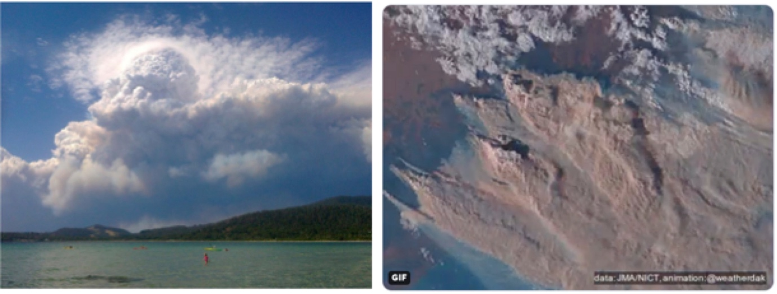
Figure 9: Left: A Pyrocumulonimbus storm arising from a severe fire on Jan 4th 2020 in NSW [twitter]. Right: Satellite footage of pyrocumulonmbus storms on Jan 4th 2020 in NSW [twitter].
Pyrocumulonimbus wildfires magnify the impact of global heating on extinction events. Fires play an important role in ecological systems and as such, flora and fauna have not only adapted to survive fire, but many components of biodiversity depend on recurrent burning. Unfortunately, intense wildfires under the influence of global heating can impact negatively on remnant species populations in fragmented bushland. In particular, a sudden loss of numbers can decrease genetic diversity in small remnant populations leading to a “near‐extinction bottleneck” [paper]. That is, even if numbers recover, there remains increasing inbreeding and less fitness in the population. Recurrent events can lead to a species becoming “functionally extinct”; a population does not encompass sufficient numbers and genetic diversity for recovery and future viability. The 2019-2020 bushfires of Australia have killed substantial numbers (possibly hundreds of millions) of animals and will have substantially increased extinction pressures on a number of native species [paper].
Recent bushfires in south east Australia have caused sudden deaths of up to 35% of local, biodiverse koala populations [media]. While koala numbers have declined by approximately 99.5% in the last 200 years, as a whole they are not considered functionally extinct, but vulnerable or critically endangered (although some of the 20 different species are likely functionally extinct) [report]. Future projections predict further declines in this iconic marsupial species [paper] so that widespread regional extinction seems likely.
5.2 Bushfires and global burned area
An important distinction exists between global bushfire risk and global burned area. Bushfire risk represents the likelihood and severity of uncontrolled fires. The transition from risk to actual bushfires depends on additional factors such as ignition and fire management. The global burned area is a composite of the area burned due to uncontrolled bushfires plus deliberate, controlled burning. Controlled burning has historically made a larger contribution to global burned area than bushfires [paper], particularly the widespread controlled burning of grasslands and savannas associated with nomadic subsistence and agricultural practices in under-developed economies in Asia, Africa and South America [paper]. As these agricultural practices have changed, the area of controlled burned area has decreased and as a result, the total burned area (controlled plus uncontrolled) has declined by approximately 25% over the past 18 years [paper]. Analyses of historical data indicate that purposeful human activities have been the dominant factor in the decline of burned area in tropics and extra-tropics, and climate variation has been the primary factor influencing the variation of burned area at high latitudes [paper].
The decrease in global burned area has been used to argue that wildfire risk is not increasing, but this is clearly not true: Research in this area has conclusively found that the primary drivers of declining fire activity have been “agricultural expansion and intensification” [paper] despite the fact that “rising temperature and frequent droughts are becoming increasingly important and expected to increase wildfire activity in many regions of the world.”[paper].
5.3 Fuel load, prescribed burning and weather
It is generally accepted that fire load (the density of flammable material) plays an important role in bushfire intensity, size and damage. Prescribed, off-season burning is the accepted way reducing fire load (particularly smaller forest litter) and legislated at a state level [report]. For this reason, Australian states legislate an annual quote of prescribed burning that is coordinated across state forests, National Parks, rural fire services and private land-owners. However, the impact of prescribed burning on fire load and biodiversity are complex [paper]. One reason for this is that fires can “cure” (dry-out) forest material, increasing rather than decreasing fuel. For example, post-burn assessments of prescribed burns in the Blue Mountains (from 1990-97) found that 30 per cent of the burns had a negative result, 40 per cent were sub-optimal, and 30 per cent could be rated as effective burns. When they are effective, fuel re-accumulation may limit their effectiveness to a short post-treatment period (2–4 years) [paper], meaning that burning would be required every 5 years. Given the enormous expanse of Australia, this limits the effectiveness of prescribed burning as a large-scale fire mitigation strategy. It is therefore targeted to decrease fire intensity near populated areas, improving subsequent fire suppression efforts at the time of fire.
While fire plays an important role in ecosystem life cycles, repeated prescribed burning in a limited area can actually decrease local biodiversity. Moreover, quantitative analysis of previous fires across SE Australia suggest that the influence of extreme weather events are up to 50 times more important than the influence of the time since the last fire. For this reason, the best results of prescribed fire are thought to be in climates where the likelihood of extreme weather conditions is low [paper]. Expert opinion suggests that controlled burning modifies bushfire behaviour, making them easier to control [media].
Naturally occurring wildfires increase carbon cycling but are thought to be close to carbon neutral when factoring in regrowth: However, extreme fire under the influence of global heating may liberate carbon from soil and turn forests into carbon emitters [paper].
Also, of note is that in NSW, only four per cent of fires start in National Parks (although they cover 7% of the state). Less than 10 per cent of fires that started in the national parks escaped the park while 20 per cent of the fires in national parks start in private property or other lands [report].

6. IMPACT OF CLIMATE CHANGE ON ECONOMIC ACTIVITY AND HUMAN MORTALITY

The impact of global heating extends beyond the natural environment. For example, global heating directly changes the number of days where productive labour can be conducted in many working environments (e.g. manual labour outside of air-conditioned environments). This can be quantified by considering the “wet bulb temperature” (WBT) which is a combination of humidity and temperature. A WBT above 31°C is generally considered dangerous to human health and incompatible with manual labour (at 30% humidity, a WBT of 31°C is approximately 47°C on a standard thermometer). Global heating increases the number of days when WBT exceeds 31°C and therefore reduces labour capacity and causes economic damage [paper]. This effect is amplified in regions where temperature is already warm, where work is largely manual (such as agriculture) and where poverty prevents access to mitigation strategies such as air conditioning, particularly in (much of) Africa, southern USA, South America, Southern Europe and many Asian countries including India and China [paper, paper]. Because the impact of high WBT days depends on existing economic wealth and means of production, the economic damage of global heating is highly heterogenous across different regions, and amplifies existing socioeconomic inequalities [paper, paper].
Due to rising temperatures, there were 45 billion potential work hours lost in 2018 compared with the year 2000 [paper]. By studying historical relationships between WBT and a variety of other human behaviours, researchers in the fledgling field of “climate econometrics” [paper] have begun to quantify other economic consequences of global heating, including on crime, suicide and energy use (Fig. 10). By doing so, it has been forecast that the combined damage of global heating across sectors (agriculture, crime, coastal storms, energy, human mortality, and labor) increases super-additively (quadratically) with global mean temperature, costing roughly 1.2% of GDP (over USD$1trillion) per year for every 1 degree of heating [paper].
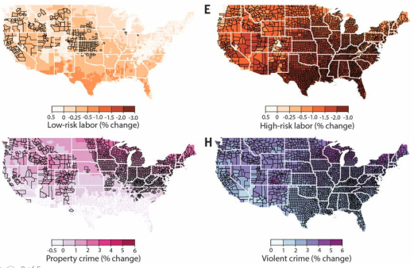
Figure 10: Economic damage from climate change in the United States. Top row: Reduced labour capacity for low-risk (left) and high-risk jobs (where) where workers are minimally or heavily exposed to outdoor temperatures. Bottom row: Projected increases in property- and violent-crime rates. Forward projections for end of 21st century based on “combustion as usual” models [paper] .
Predicted changes in WBT can also be used to model changes in death due to global heating. Human exposure to WBT of 35°C (50°C at 35% humidity) for a few hours will result in death even for the fittest of humans in shaded, well-ventilated conditions [paper]. Those countries most vulnerable to economic damage from global heating are also vulnerable to heat-related deaths and the occurrence of deadly heat-waves [paper] .
A case in point is India, a sub-tropical country with a high population density, low GDP and high dependence on agriculture (Fig. 11). India is the target for Australia’s expanding coal export market with some proponents arguing that coal-fired energy production is required to “lift people out of poverty”. However, like other regions with these demographics, India will experience disproportionate deaths and economic damage from global heating [paper, paper] .
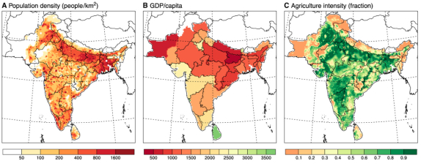
Figure 11: Due to its high population density, low GCP per capita and high agricultural dependence, India is particularly susceptible to deaths and economic from global heating due to high exposure to extreme heatwaves [paper].
The impact of global heating on mortality shows substantial geographical variability: More deaths due to increased hot days in warm climates are partly offset by less deaths due to less cold days in cold climates. However, even when taking this into account research global mortality strongly increases with global heating (Fig. 12) [paper]. This relationship between global heat-related mortality and global heating remains after factoring projected increased income and adaptation (for example through increased air conditioning). In contrast, adaptation (such as better housing) has already eliminated excess winter deaths [paper].
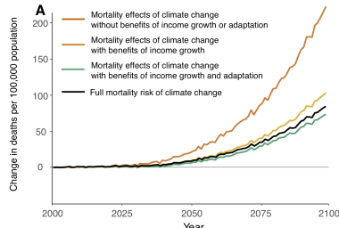
Figure 12: Projected mortality risk of climate change with current levels of emissions growth. Each coloured line represents a partial mortality effect, while the black line shows the full mortality risk, accounting for both adaptation costs and benefits [paper].
Children and older adults are most susceptible to deaths associated with high WBT [paper]. This age effect (particularly in children) magnifies the disproportionate impact of global heating on underdeveloped regions, where children constitute a higher proportion of the population demographics.
Climate econometrics thus predict substantial economic damage and increased mortality risk with global heating. These costs underlie the enormous world-wide subsidies for fossil fuels, which reflect the gap between existing prices and the full price warranted by supply, environmental and health costs. For example the IMF (the international monetary fund) estimates that global fossil fuel subsidies are approximately US$5trillion per annum, or 6.5% of GDP (this is the sum that national governments effectively pay across all sectors to support the consumption of fossil fuels at their current supply cost) [paper, report]. These subsidies are also heterogenous, with Australia paying one of the highest per capita rates (US$1200 per person) and India one of the highest in economic terms (10% of GDP). The World Bank has recently estimated that global heating could push an extra 100 million into poverty and create hundreds of millions of “climate migrants”, as people seek more viable places to live [report].
As a relatively new field, climate econometrics has matured quickly to encompass a variety of risk factors (including the WBT), their interactions and mitigation [paper]. However, climate econometrics mainly focus on the direct effect of these risks on economic and health risks, and do not currently incorporate the risks associated with other changes in the natural environment [paper], including the risks associated with collapse of keystone species such as plankton and insects, whose impact on ecological systems, economic damage and human wellbeing could be quite catastrophic [paper]. More formally,
“Because different species respond at different rates and to varying degrees, key interactions among species are often disrupted, and new interactions develop. These idiosyncrasies can result in rapid changes in ecosystem functioning, with pervasive and sometimes unexpected consequences that propagate through and affect both biological and human communities.” [paper]
In light of this, projections of economic damage and mortality that do not factor in fundamental ecological re-organization or collapse should arguably be considered very conservative.
7. ACTION TO ARREST FURTHER CLIMATE CHANGE
In the public domain, some of those accepting the science of man-made climate change question the feasibility of action based on the perceived economic cost of transitioning away from burning fossil fuels for energy and transport. This section canvasses technological and economic research which unambiguously show that mitigating future global heating through “decarbonization” is feasible and cost effective.
7.1. Transitional technologies
As discussed above, global heating depends on the Equilibrium Climate Sensitivity (ECS), which relates atmospheric CO₂ concentration to atmospheric temperature. Surface and land and ocean temperatures have currently heated by approximately 1°C. If global CO₂ emissions continue to grow according to current trends, temperatures will be between 3 and 5°C hotter by 2100 (Fig. 13), a level which will multiply the damage to ecosystems, health and economies. As outlined above, these impacts increase linearly or super-linearly with global heat, and conversely every strategy that effectively reduces future climate heating reduces these harms: Current international efforts aim to limit further heating to 0.5°C to contain these effects [report].
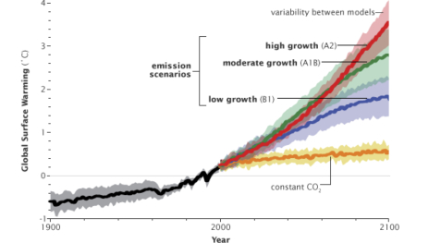
Figure 13: Model simulations estimates of global heating under different assumptions of GHG emission growth. Red: Heating with no change in emission growth. Blue: Low emission growth: Orange: Hypothetical heating with GHG levels at year 2000 levels [report].
Global heating reflects the combined effect of increasing “greenhouse gases” (GHG) which includes CO₂, methane and nitrous oxide. Stabilizing GHG concentrations, particularly CO₂ (“decarbonization”) requires large-scale transformations in the way that we produce and consume energy, and how we use the land surface [report, site]. Several points are salient here:
1. Using existing and emerging technologies, there exist clear pathways to a substantial decarbonization across all sectors of production (Fig. 13) [paper, paper, paper]. These include transformations in energy, manufacturing, digital technologies, buildings, transport, food, as well as the development of novel “nature-based solutions” [report]. Almost all of this transformation can be achieved through up-scaling of existing technologies. One challenge includes carbon-neutral technologies for conversion of iron ore to steel (due to the high temperatures required for the blasting process). Addressing this challenge is the objective of several of the world’s largest manufacturers and is close-to-achievable [report].
Executing the transition presents challenging economies of scale and cannot be achieved without a strategically planned timeline, particularly in temperate climates with a high population density [site]. Australia’s low population density and high solar irradiance place it at highly strategic advantage for renewables: For example Australia’s entire electricity budget could be derived from solar panels alone covering less than 0.5% of the country [report]. In practice, the optimal mix of renewable energy in Australia will likely be a mix of solar, wind and geothermal [report].
2. To limit global heating to a further 0.5°C (total 1.5°C) requires immediate reductions in GHG emissions with a goal of zero net emissions by 2050. In particular, a decisive breakpoint (technically, a discontinuity in trend derivatives) is required to unlock global emissions from their current upward growth to an immediate, sustainable reducing trend [report]. Globally, GHG emissions are not showing evidence of this breakpoint, either in existing GHG emissions (which are at best slowing or otherwise continuing to grow), or in new emission policies. Australia, for example, continues to expand its major CO₂ exports with new coal mines, such as the Carmichael mine, receiving billions of dollars in subsidies [site] for low quality, high ash coal [site] that is destined for regions that are particularly vulnerable to the impact of global heating, such as India.
3. Renewable energy (such as solar, wind, thermal, hydro) will play a crucial role in the decarbonization of society (Fig. 14) [paper] Energy production is a major source of global CO₂ emissions, with flow-on effects to other sectors including transport, manufacturing, digital technologies and food storage.
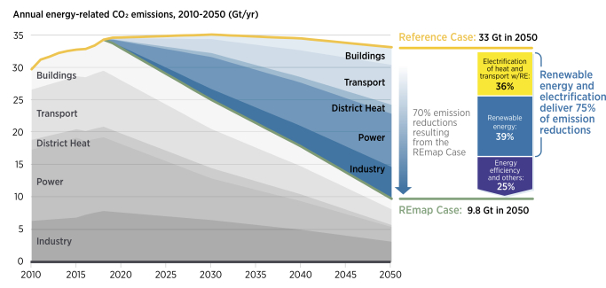
Figure 14: Renewable energy and energy efficiency can provide over 90% of the reduction in energy-related CO2 emissions [report]: Projected annual energy-related CO2 emissions and reductions, 2015-2050 (Gt/yr) under a low emission growth scenario. Note the very sharp change in the use of CO₂-based energy necessary in ~2020.
Both fossil-fuel and renewable power technologies carry life-cycle GHG emissions, mainly due to their construction and operation. However, when taking these factors into account, solar and wind emissions are less than 10% of fossil fuel-based power generation, even if these use advanced carbon capture and sequestration technologies [paper].
Transition to solar and wind also reduce air pollutants (“particulate matter”), bringing additional benefits for air quality in addition to heat mitigation [paper]. As a consequence of this benefit, decarbonization through renewable energy will avoid 0.5, 1.3 and 2.2 million premature deaths in 2030, 2050 and 2100 in addition to those avoided by unmitigated global heating [paper]. Because of the high premium that society places on avoiding death, the costs of changing electricity production to renewables will be substantially offset by reduced pollution-related mortality, especially in China and India [paper]. Under a low emission scenario, these savings exceed the costs of the associated decarbonization of the energy sector by 2050 [paper]. These savings are in addition to the benefits of mitigating global heating, but as they occur mainly locally, in the near term, and with high certainty, they contrast with the long-term distributed global benefits of slower heating, and therefore should further incentivize decarbonization at the national level (particularly in China and India) [paper].
The costs of renewables have plummeted exponentially over the last decade (Fig. 15). In 2018 alone, the global weighted-average cost of renewable electricity declined 26% for concentrated solar power (CSP), followed by bioenergy (14%), solar photovoltaic (PV) and onshore wind (both 13%), hydropower (12%), and geothermal and offshore wind (both 1%) [report]. As the cost of renewable energy continues to decline, certain renewable technologies (e.g. onshore wind and utility-scale solar), have now been cost-competitive with conventional coal and nuclear generation for several years, on a new-build basis [report]. These costs are cheapest for large-scale (wholesale) projects, followed by industrial and commercial, and most expensive when deployed residentially.
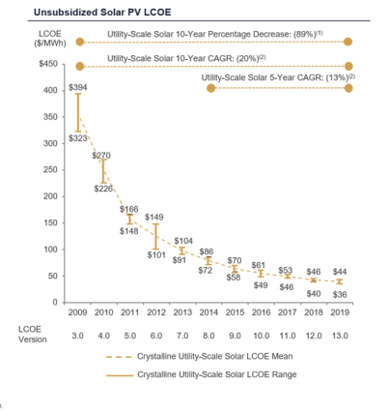
Figure 15: Exponential decreases in the levelized (whole cycle) costs of electricity (LCOE) from solar photovoltaic over the last decade [report] .
One criticism of solar and wind (but not hydro) has been their itinerant dependence on sun and wind. Concentrated solar power (CSP) generates electricity by using sunlight to heat a fluid. The heated fluid is then used to create steam that drives a turbine-generator set. Because CSP systems heat a fluid prior to generating electricity, thermal energy storage can be readily incorporated into the design of CSP plants, making them a source of “dispatchable” and 24-hour renewable power [report]. The cost of CST is expected to fall as it is further deployed around the world [report].
In sum, there are compelling economic and health benefits supporting the transition to renewable energy production, in addition to the mitigation of damage from global heating.
4. Decarbonizing the society does not require a reduction in total energy usage, or a contraction in economic growth (Fig. 14). On the contrary, the development and installation of renewable energy sources represent substantial economic and employment opportunities [site] – the private sector is already playing a pro-active role here [media]. To minimise economic disruption, decarbonization requires a planned, strategic and staged approach guided by achievable time posts [paper] . A crucial social component of this process is the implementation of a “just transition” whereby communities currently dependent on GHG-based industries (such as coal mining) are selectively targeted by government policies to incentivize their prioritized role in new non-CO₂ economic opportunities [report]. Some of this could be achieved by re-directing current billion-dollar subsidies from CO₂-based industries to carbon neutral industries. Independent strategic and advisory bodies have also requested greater policy certainty in this area [report], such as definitively resolving the prevailing government uncertainty over the construction of new coal-based power plants in Australia, financed “Soviet-style” by central government [media, media].
5. Carbon sinks play a major role in off-setting current GHG emissions and currently account for some recent slowing in the total GHG budget in the face of rising emissions. For example, in Australia, this (land use and forestry) sector is almost entirely responsible to improvements in the GHG emission budget [report], mainly through a decline in the harvesting of native forests, although partly through a maturation of plantation forests planted in the 1990s [report].
Global tree cover has increased slightly since the 1980s [paper]: Loss of tropical forests has been outpaced by increased woody growth in increasingly warmer regions of Northern Siberia and global sub-alpine mountainous regions. Although this is partly due to active reforestation policies in some regions (such as China), it is generally an inadvertent by-product of changes in human activity. For example, following the collapse of the Soviet Union in the 1980s, natural afforestation occurred on abandoned agricultural land in Eastern Europe [paper, paper]. The improved carbon balance in Australia’s land-use sector largely reflects the maturation of forest plantations planted in the 1990s, decreased carbon liberation from soil due to changes in agricultural tilling and decreased logging of native forests [report]. The first of these does not reflect contemporary carbon mitigation policies.
Restoration of tree cover at a global scale could substantially help mitigate climate change. It was recently shown that there is room for an extra 0.9 billion hectares of canopy cover, which could store 205 gigatonnes of carbon in areas that would naturally support woodlands and forests [paper]. Note that this is a ten-fold increase in the tree cover that has occurred since 1980 and would require substantial active government initiatives. Also, almost a quarter of this potential could be lost due to global warming by 2050. Moreover, as we have seen in Australia, global heating leads to faster drying and shorter windows for load-reduction through controlled burning [report]. In addition, fire suppression costs increase approximately 6-fold with high burn severity [paper], another consequence of global heating. Moreover, fire suppression is less effective in the presence of severe wind and heat events [paper] . Hence, although reforestation is an important component of GHG reduction, it requires careful strategic and economic planning. Habitat restoration to slow the decline of native species such as the Koala likely to represent only a very small total area of reforestation [report].
Offsetting GHs via reforestation can be seen as one of a broader range of “Negative emission technologies (NETs) which include industrial processes, such as carbon capture and sequestration, and direct air carbon capture and storage, plus ecosystem approaches including soil carbon sequestration biochar, blue carbon, enhanced weathering, and ocean fertilization [paper]. NETs are of relevance since they potentially allow accelerated decarbonization, particularly in light of inaction on other fronts (Fig. 16). However, although in active development, they are unlikely to be scale-able until well after 2030 [paper].
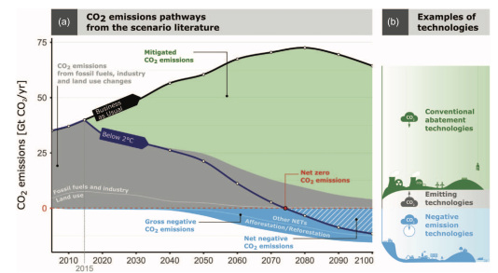
Figure 16. The potential role of NETs (blue) in decarbonization (paper).
7.1. So, what is “climate alarmism”?
One often hears the term “climate alarmist” made against those who argue for immediate reduction of GHG emissions – indeed the words “alarmist” and “doomer” seem to have been weaponised on social media. The confusion likely arises because of the lag between current global CO₂ levels and future global heating (e.g. see the heating associated with constant CO₂ emissions; orange line in Fig.14). Hence the need for immediate effective action to limit future global heating and associated damage. Harmful, possibly irreversible, ecosystem changes will be locked in by 2030 if CO₂ emissions continue to rise at current rates – well before those damages will be fully apparent. Under this scenario, mitigation to limit further heating to 0.5°C will not be feasible. It seems that the nuance between the urgency of effective action and the lag before further global heating is lost in the not-so-subtle world of social media.
Evidence reviewed above suggests that decarbonizing the economy by 2050 is cost effective, feasible, compatible with economic growth, and consistent with a mix of government policy and private sector investment. Put differently, taking this action is agnostic to the need for major structural economic or political change, although it does require that the technical advice of scientists is given greater weighting in decision making than is currently the case. Conversely, failure to effectively mitigate global heating will increase ecological and economical damage, placing greater duress on prevailing political systems and hence making those systems more vulnerable to social conflict and disruption [paper].
In light of these considerations, the term “alarmism” is arguably a more accurate description of arguments that suggest effective action on climate action is economically damaging or a disguised means of co-opting public goodwill for political change
There exist several claims in the public domain that the climate is not changing, or the change is part of natural variation, or is not due to human activity:
8.1 Data manipulation?
Remarkably, at least to me, there have been allegations that the Australian Bureau of Meteorology has systematically fabricated the data underlying the climate reports (and I assume by extension, also the American Society of Meteorology, the editors of the Bulletin of the American Society of Meteorology, NASA and many other scientific bodies [site]). I say remarkably, because I see no reason for scientists to fabricate their data and no means for this to be coordinated nationally or internationally. Moreover, data fabrication in science constitutes major misconduct, leading to termination of employment, retraction of papers and even criminal prosecution in the courts [report].
A central claim underlying this allegation is that the official mean data is not the simple average of raw data. But unless temperature recordings are taken on a uniform global grid (i.e. at regular spatial intervals everywhere), which is impossible, and with no historical change in instrumentation– also impossible – then further processing is a mandatory component of time series analysis: This process, which has been peer-reviewed [paper], is performed with slight modifications in many scientific fields, including neuroscience. Moreover, weather records with and without these standard data analysis steps are available for download in the public domain [site] and both show clear warming trends. The Bureau have published a firm rebuttal to these claims [site]
Notably, estimates of global heating are evident when inferring temperature from other meteorological observables including barometric pressure [paper] and from recent satellite estimates of global temperature in the mid- to upper troposphere [paper] making claims regarding data fabrication irrelevant and vexatious.
8.2 Scientists justifying their salary?
On a related note, one sometimes reads allegations that (thousands of) climate scientists have fabricated the data behind global heating in order to justify their own funding. This is extremely implausible for a number of reasons. For a start, salaries in science are substantially below (<50%) those for equivalent expertise in the private sector: A person possessing advanced data analysis skills, report preparation, programming and forecasting can easily obtain employment at much higher salary (and job security) in the finance, insurance, IT or even mining sector: Moving into the private sector to increase income and career security is a common choice among researchers at all levels of seniority and offers a far simpler solution than data manipulation and systematic violation of research integrity. Second, climate science is funded in competition with other areas and assessed by scientists in other fields such as neuroscience. Data manipulation is typically easy to spot and indeed, instances of scientific fraud, when they do occur, have been invariably detected by other scientists. It is not feasible that scientists in other fields, competing for the same pool of money, would be blind to such widespread systematic malpractice and agree to the awarding of competitive funds that might otherwise come to their own field.
It is far more likely and, by Occum’s razor, far simpler that the data analysis is being conducted according to best practice and that scientists are not embroiled in a coordinated collusion of deception but rather accurately documenting the consequences of increased atmospheric CO₂.
8.3 Underwater volcanoes and solar radiation?
There also exist sporadic claims that global heating arises from an increase in the activity of deep ocean volcanoes, heating the ocean, causing sea level rises and the release of heat into the atmosphere. This is a highly implausible cause of global heating for a number of reasons: There is no evidence for any increase in volcanic activity; Ocean temperatures at surface (and down to 2000m) have warmed whereas temperatures at deeper levels have not warmed [paper] (contrary to heating from deep ocean volcanoes); and this mechanism does not explain the increase in oceanic carbonic acid (and the reducing ocean pH), nor the clear link between combustion of fossil fuels and increasing atmospheric carbon dioxide.
Likewise, there exist sporadic claims regarding a causal link between solar irradiance and global heating. However, there is no evidence of an upward trend in solar irradiance to substantiate this claim [site]. As with underwater volcanoes, this claim is also inconsistent with many other observations: Global heating of the atmosphere is greatest at surface level, not in the upper atmosphere, and it cannot explain the increase in atmospheric carbon dioxide.
8.4 It’s “just modelling”
The causes and impacts of global heating are occasionally derided because they are “just based on models”. The evidence for global heating and the causative influence of human activity, as reviewed above, constitute strong scientific evidence. Much of the link between heating and harm are based upon surveys of historical associations (such as the impact of WBT on health and death risk), have already been subject to “out of sample” validation [paper] and therefore do not depend upon explicit causative models.
Models play a central role in all branches of scientific enquiry and are core to the endeavour to extract general principles from empirical observations – in fact models (such as the theory of optics) lie at the heart of those observations (such as planetary motion). Newton’s law of motion (F=ma) is a “model”, couched in the same branch of mathematics (calculus) used in weather and climate prediction. Putting “man on the moon” was at its core an exercise in solving the laws of motion and, as such, remained a model prediction until the moment humans actually landed on the moon. Therefore, to critique a branch of science due to its use of mathematical models is a complete misunderstanding of the core principles of scientific enquiry.
Meteorological modelling and model simulations play a core role in climate science, as they should. These models are based on well-established physical principles (such as the flow of atmospheric gases and the separation of time-scales) and subject to state-of-the-art development, empirical validation, refinement and large-scale simulation [paper]. No weight should be given to criticisms about climate science because of its employment of modelling.
8.5 An “Act of God”?
Putting aside the existence of God, there currently exists a compelling scientific account of global heating under the influence of anthropogenic GHG emissions. While the causative link between human activity and global heating may have been unknown historically, it is now well documented, justified and available in the public domain. There are no gaps in physical explanation through which God could impose his will and likewise no means through which “thoughts and prayers” could modify the effects of global heating on human welfare.
Assuming (consistent with major world theologies) that God endowed humans with free will, we now accordingly choose freely (or not) to take action to mitigate future damage to ecological systems and human health through changes in policy and behaviour. Therefore, even if God exists, global heating and the associated damage (e.g. from days of WBT>35°C) are not “Acts of God” but rather “Acts of (hu)man”.
This may seem like an obscure or even facetious point, but it is important because it makes those entities (humans, corporations) who freely choose to increase GHG emissions vulnerable to future class action [site]. To put this in perspective, several thousand residents of Brisbane were recently awarded up to AUD$1billion in a class action for flood damage against the operators of flood mitigation dams, Seqwater and Sunwater [report]. Rough estimates (see above) equate a minimum damage of $1billion for every 0.001°C of additional heating due to GHG emissions every year. Class actions against those who choose to add unnecessary burden to global heating would dwarf short-term profits, particularly to those who enable small but critical infrastructure links to large CO₂-emitting projects [site]:-
As time passes, however, and as climate change starts to affect the value of companies, and investors suffer losses, it seems inevitable that plaintiffs will begin to claim damages for these types of breaches by companies and their directors. Those claims might attract the interest of litigation funders, and come in the form of securities class actions.
A further possibility is that claims will be brought connected with misleading conduct in the case of major emitters if they are found to have recognised the risks of climate change (and their contribution to it) some time ago, but have actively taken steps to undermine public recognition of or belief in it, thereby contributing to delay in responding to the risks. Litigation of this type has started to emerge in the US, with local government as the plaintiffs.
Taxpayers should also be mindful that class actions can be mounted against governments, even for historical actions [site]:-
To the extent that governments make decisions (or implement policies) which seem to support ongoing or increasing emissions by industries or entities which contribute meaningfully to Australia’s overall level of emissions, these types of actions may be taken against both governments, and the beneficiaries of those policies,
8.6 A brief reflection on science and public knowledge
In sum, counter-claims to the body of knowledge that links GHG emissions to climate change are spurious and easily rebutted. Nonetheless, they are effective at short-circuiting important strategic decisions to decarbonize the economy, bringing debate back to issues that were essentially resolved in the scientific literature decades ago.
As a scientist, it is disappointing to see the claims outlined above appearing repeatedly in the public domain, often supported by a link to a youtube video or a blog. I find the claims of data manipulation and systematic collusion puzzling and even demoralizing. Where does this derision of scientists derive? The undercurrent of the claims runs completely at odds with my personal experience as a scientist (and medical doctor) that scientists are overwhelmingly open, altruistic, collegial and ethical– often foregoing opportunities in financial sectors that offer greater remuneration and job security for the implicit reward of knowledge discovery. Scientific enquiry is also characterized by a rich tradition of critical enquiry. That is, scientists are trained to critically appraise existing knowledge, using quantitative techniques to improve or refute theory and models. The claims that scientists accept climate science, or worse, fabricate narratives, for reasons of naivety or financial gain are prohibitively unlikely.
Like most contemporary politics, much of the polemics around climate science are currently mediated through the medium of social media. In my experience, it seems that social media can both support the dissemination of science (at least amongst scientists), but also undermine the (apparently) privileged place of science as a source of reputable knowledge. Occasionally this is justified by giving “both sides of the debate” a voice, even when the burden of scientific evidence is overwhelming. Nonetheless, “most” scientific discoveries – new and old – remain widely celebrated across most sectors of society, from Einstein’s work on relativity to the recent detection of gravitational waves. The denigration of science on social media seems confined to the science of climate change.
Climate science, on my reading, sets very high standards of reproducibility, technological excellence, open science (including data availability) and collaboration. For example, the advanced use of data assimilation in weather forecasting (modifying model predictions on-the-fly using real-time data) is far more advanced than its current applications to seizure prediction in neuroscience (an area where I work). Also notable is how climate predictions, through the use of “ensemble models” (vast parallel computer simulations) not only yield expected outcomes but also the uncertainty of those predictions. On paper, climate science is one of the fields that is least vulnerable to issues of reproducibility that have been identified in other fields, such as in small lab driven psychological research – and already employs many of the strategies that have been identified as solutions to these issues (models based on physical principles, data sharing, open collaboration, convergence between different model predictions). In my opinion, the debate surrounding climate science has nothing to do with internal scientific standards within the field and currently nothing to do with existential threats to free market economics. Addressing climate change decarbonization only represents a challenge to the power and wealth of those commercial entities dependent on carbon-based energy production. This selective challenging of a field of science recapitulates the fact that “knowledge” is historically always embedded in social power structures [report].
The disavowal of climate science extends beyond those immediately benefitting from the current reliance on GHG emissions for economic gain to also comprise some sections of the general community, although this number appears to be decreasing [report]. There has been some informative research on the demographics and belief systems of those who disavow the science of climate change,
“Although nearly all domain experts agree that carbon dioxide emissions are altering the world’s climate, segments of the public remain unconvinced by the scientific evidence. Internet blogs have become a platform for denial of climate change, and bloggers have taken a prominent role in questioning climate science. … We show that, above and beyond endorsement of free markets, endorsement of a cluster of conspiracy theories predicted rejection of climate science as well as other scientific findings. Our results provide empirical support for previous suggestions that conspiratorial thinking contributes to the rejection of science. Acceptance of science, by contrast, was strongly associated with the perception of a consensus among scientists” [paper].
In my own experience, scepticism of climate science appears to include those who do not otherwise appear to embrace conspiratorial thinking. However, there are other apparent determinants. In the USA, males who identify as politically conservative are significantly more likely than are other Americans to disavow climate science, even more so for those conservative males who self-report understanding global warming very well [paper]. Gender also has a significant effect in Australia, with women more likely to think that climate change is caused by human activity [report]. Men polled were also less concerned than women about the consequences of climate change. Women (77%) were also more likely than men (66%) to support early action on climate change. And whereas young Australian adults overwhelmingly endorse climate science and the need for action, the level of consensus among older Australians is far more ambivalent [report].

SOURCE MATERIAL

1. CLIMATE CHANGE, THE AUSTRALIAN CONTEXT

Papers:
Impact of anthropogenic climate change on wildfire across western US forests
Attribution of the Influence of Human‐Induced Climate Change on an Extreme Fire Season
Reports:
Australian Rainfall, Spring 2019 (Bureau of Meteorology)
Lowy Institute Polls, 2019: Climate change and energy
Australia’s emissions projections 2019
Quantifying CO2 from Australia’s fossil fuel mining and exports
NASA: Global Climate Change
State of the Climate (Bureau of Meteorology)
CSIRO: Top 10 Achievements
IPCC Assessment Reports

2. IS THE CLIMATE CHANGING?

Papers:
No evidence for globally coherent warm and cold periods over the preindustrial Common Era
State of the Climate in 2018 (Bulletin of the American Meteorological Society)
Independent confirmation of global land warming without the use of station temperatures
Tropospheric Warming Over The Past Two Decades
Global reconstruction of historical ocean heat storage and transport
Reports:
State of the Climate (Bureau of Meteorology and CSIRO)
Scientific Websites:
October 2019; Temperature Update (Berkeley Earth)

3. IS CLIMATE CHANGE DUE TO HUMAN ACTIVITY?

Papers
A probabilistic analysis of human influence on recent record global mean temperature changes
Man-made carbon-dioxide and the “Greenhouse effect”
Climate impact of increasing atmospheric carbon dioxide
Global climate change as forecast by Goddard Institute for Space Studies three dimensional model
Twentieth century temperature trends in CMIP3, CMIP5, and CESM-LE climate simulations: Spatial-temporal uncertainties, differences, and their potential sources
State of the Climate in 2018 (Bulletin of the American Meteorological Society)
Independent confirmation of global land warming without the use of station temperatures
Tropospheric Warming Over The Past Two Decades
Climate Change 2013: The Physical Science Basis
Observational constraints on mixed-phase clouds imply higher climate sensitivity
Reports
State of the Climate (Bureau of Meteorology and CSIRO)
Scientific websites
Climate at Glance: Global Time Series (NOAA)
Seabreeze (Newcastle)
How well have climate models predicted global warming? (Carbon Brief)
Scientific Consensus: Earth’s Climate is Warming (NASA)

4. IS IT “NORMAL VARIATION”?

Papers
Accelerated modern human–induced species losses: Entering the sixth mass extinction
Humans are driving one million species to extinction
More than 75 percent decline over 27 years in total flying insect biomass in protected areas
Worldwide decline of the entomofauna: A review of its drivers
The projected effect on insects, vertebrates, and plants of limiting global warming to 1.5°C rather than 2°C
Patterns and causes of extinction and decline in Australian conilurine rodents
Forecasting wildlife die‐offs from extreme heat events
Climate change and the effects of temperature extremes on Australian flying-foxes
Drought-driven change in wildlife distribution and numbers: a case study of koalas in south west Queensland
Darcy’s law predicts widespread forest mortality under climate warming
Spatial and temporal patterns of mass bleaching of corals in the Anthropocene
A new, high-resolution global mass coral bleaching database
Global warming transforms coral reef assemblages
Warming Trends and Bleaching Stress of the World’s Coral Reefs 1985–2012
Global warming and recurrent mass bleaching of corals
Longer and more frequent marine heatwaves over the past century
The unprecedented 2015/16 Tasman Sea marine heatwave
Disease epidemic and a marine heat wave are associated with the continental-scale collapse of a pivotal predator
Marine Heat Waves Hazard 3D Maps and the Risk for Low Motility Organisms in a Warming Mediterranean Sea
Local Extinction of Bull Kelp (Durvillaea spp.) Due to a Marine Heatwave
Climate Impact on Plankton Ecosystems in the Northeast Atlantic
Biogeochemical Controls and Feedbacks on Ocean Primary Production
Sites
The Flying Fox
The Flying Fox Heat Stress Forecaster
Media
Killer climate: tens of thousands of flying foxes dead in a day

5. CLIMATE CHANGE AND BUSHFIRES

Papers
Observed Impacts of Anthropogenic Climate Change on Wildfire in California
Warming and Earlier Spring Increase Western U.S. Forest Wildfire Activity
Impact of anthropogenic climate change on wildfire across western US forests
Attribution of the Influence of Human‐Induced Climate Change on an Extreme Fire Season
Climate change and disruptions to global fire activity
Future changes in extreme weather and pyroconvection risk factors for Australian wildfires
Climate Change Increases the Potential for Extreme Wildfires
Low genetic variability of the koala Phascolarctos cinereus in south‐eastern Australia following a severe population bottleneck
As fires rage across Australia, fears grow for rare species
Use of expert knowledge to elicit population trends for the koala (Phascolarctos cinereus)
Climate and human influences on global biomass burning over the past two millennia
A human-driven decline in global burned area
Spatial and temporal patterns of global burned area in response to anthropogenic and environmental factors: Reconstructing global fire history for the 20th and early 21st centuries
The Interaction of Fire, Fuels, and Climate across Rocky Mountain Forests
A review of prescribed burning effectiveness in fire hazard reduction
Fire, Global Warming, and the Carbon Balance of Boreal Forests
Reports
Bushfire weather
State of the Climate (Bureau of Meteorology and CSIRO)
The Koala – Endangered or Not?
Is Fuel Reduction Burning the Answer? (Brief to the Australian Parliament, Dec. 10, 2002.
Media
To save koalas from fire, we need to start putting their genetic material on ice
How effective is bushfire hazard reduction on Australia’s fires?

6. IMPACT OF CLIMATE CHANGE ON ECONOMIC ACTIVITY AND HUMAN MORTALITY

Papers
Reductions in labour capacity from heat stress under climate warming
Global non-linear effect of temperature on economic production
Estimating economic damage from climate change in the United States
The 2019 Report of The Lancet Countdown on Health and Climate Change.
Deadly heat waves projected in the densely populated agricultural regions of South Asia
Climate Econometrics
Valuing the Global Mortality Consequences of Climate Change Accounting for Adaptation Costs and Benefits
Climate warming will not decrease winter mortality
The Structure of Economic Modeling of the Potential Impacts of Climate Change: Grafting Gross Underestimation of Risk onto Already Narrow Science Models
Climate tipping points — too risky to bet against
Biodiversity redistribution under climate change: Impacts on ecosystems and human well-being
How Large Are Global Energy Subsidies?
Reports
Global Fossil Fuel Subsidies Remain Large: An Update Based on Country-Level Estimates
Climate Change: Overview (The World Bank)

7. ACTION TO ARREST FURTHER CLIMATE CHANGE

Papers
Meeting the world’s energy needs entirely with wind, water, and solar power
Roadmaps to Transition Countries to 100% Clean, Renewable Energy for All Purposes to Curtail Global Warming, Air Pollution, and Energy Risk
Providing all global energy with wind, water, and solar power, Part I: Technologies, energy resources, quantities and areas of infrastructure, and materials
Providing all global energy with wind, water, and solar power, Part II: Reliability, system and transmission costs, and policies
Meeting the world’s energy needs entirely with wind, water, and solar power
Understanding future emissions from low-carbon power systems by integration of life-cycle assessment and integrated energy modelling
Public health benefits of strategies to reduce greenhouse-gas emissions: low-carbon electricity generation
Co-benefits of mitigating global greenhouse gas emissions for future air quality and human health
Global land change from 1982 to 2016
Eastern Europe’s forest cover dynamics from 1985 to 2012 quantified from the full Landsat archive
The global tree restoration potential
Changes in potential wildland fire suppression costs due to restoration treatments in Northern Arizona Ponderosa pine forests
Wildlife decline and social conflict
Negative emissions—Part 1: Research landscape and synthesis
Negative emissions—Part 2: Costs, potentials and side effects
Negative emissions—Part 3: Innovation and upscaling
Reports
Scaling 36 Solutions to Halve Emissions by 2030 (Exponential Roadmap)
Global warming of 1.5°C: IPCC report
Assessing Transformation Pathways: IPCC report
Our vision of climate-neutral steel: renewable energies as an enabler
Mitigation Pathways Compatible with 1.5°C in the Context of Sustainable Development
Global energy transformation: A roadmap to 2050 (2019 edition)
The future of solar energy (MIT)
Concentrated solar thermal (Australian Government)
Guidelines for a just transition towards environmentally sustainable economies and societies
Electricity market (The Australian Energy Market Commission (AEMC))
Australian Land Use, Land Use Change and Forestry Emissions Projections to 2030
Bushfire weather (Bureau of Meteorology)
Draft South East Queensland Koala Conservation Strategy 2019–2024
Scientific websites:
How Much More Will Earth Warm? (NASA)
Adani’s Thermal Coal Mine in Queensland Will Never Stand on Its Own Two Feet
Fact check: Is Australian coal really cleaner than Indian coal? And does it even matter?
The 10GW solar vision that could turn Northern Territory into economic powerhouse
Sustainable Energy – With the Hot Air
Media
Atlassian boss Mike Cannon-Brookes is funding the world’s largest solar farm here to sell energy to Asia via a cable
Australia needs its old coal generators, but it doesn’t need a new one
NEG will replace electricity markets with Soviet-style state planning

8. WHAT IS NOT CAUSING GLOBAL HEATING

Papers
A daily homogenized temperature data set for Australia
Independent confirmation of global land warming without the use of station temperatures
Tropospheric Warming Over The Past Two Decades
Global reconstruction of historical ocean heat storage and transport
Deadly heat waves projected in the densely populated agricultural regions of South Asia
An Anatomy of the Motivated Rejection of Science
Cool dudes: The denial of climate change among conservative white males in the United States
Reports
Australia’s first criminal prosecution for research fraud (QLD Crime and Corruption Commission)
Queensland Floods Class Action (Supreme Court of NSW)
Archaeology of Knowledge
Websites
List of Worldwide Scientific Organizations that hold the position that Climate Change has been caused by human action
Climate Data Online
Bureau of Meteorology Media Statement – Climate Records
Is the Sun causing global warming?
Analysis: How well have climate models projected global warming? (Carbon Brief)
A new era of climate change litigation in Australia?

